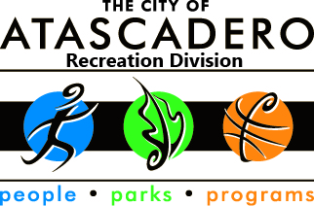
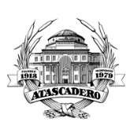
City of Atascadero
Recreation Division
5599 TrafficWay, Atascadero, CA 93422

2020 Saturday in the Park Concert Series

The City of Atascadero Recreation Division is once again looking for performers for the Saturday in the Park, Summer Concert Series. The Concert Series will consist of ten (10) concerts on the following dates: June 13th, June 20th, July 11th, July 25th, August 1st, August 22nd, August 29th, September 5th, September 12th, and September 19th 2020. All concerts are held at the Atascadero Lake Park Bandstand from 6:30-8:30pm and are free to the public. We have had an average attendance of over 500 at all concerts for the past 17 years and we plan to increase participation even more for 2020!

We are currently accepting applications from bands for our 2020 Concert Series. We ask that you complete and return the application that’s included along with a labeled demo CD, a band photograph, and any relevant press and history on your band. Applications and band information must be received no later than Friday, February 7, 2020 at 5:00 pm in order to have our line-up secured and advertising material out in a timely manner. We cannot accept late applications.

Advertising for the 2020 series will consist of the following:

Concert Series Banner - Listing only performance dates, times, and presenting sponsor information; to be displayed on Highway 41 at the entrance to the Atascadero Lake Park.

Concert Series Posters –Band names along with performance dates, times, and sponsor information will appear on all posters; to be distributed to local businesses throughout the community.

Concert Series Website – Band names, photos, members, and history along with performance dates, times, and sponsor information will appear on the website hosted by the City of Atascadero at www.atascadero.org.

Other Website Listings – Band names, photos, performance dates, times, and sponsor information will appear on the following websites: www.visitatascadero.com and www.visitslocounty.com

Press Releases - Band names, performance dates, and times will be sent in weekly press releases to all local media, including KSBY, The Tribune, KCOY, New Times & Atascadero News.

Summer 2020 Atascadero Recreation Guide - Band names, photos and history along with performance dates, times, and sponsor information will be printed. The Recreation Guide will be distributed to over 20,000 households and businesses in Atascadero.

After reviewing applications, a demo screening will be held and the bands will be selected by a review committee. Performance availability sheets will be emailed to each selected band and every effort will be made to accommodate your requests for performance dates. All selected bands will be paid a one-time $300 performance stipend on the evening of the respective concert. The City of Atascadero will provide an audio technician for each concert. We are unable to honor requests to use personal/band audio systems. The audio technician will contact you prior to your performance regarding your specific needs.

If you have any questions, or for more information regarding the Saturday in the Park Summer 2020 Concert Series, please feel free to e-mail me at jfanning@atascadero.org or call me at (805) 470-3426.

Sincerely,

Jennifer Fanning
Jennifer Fanning
Recreation Supervisor

