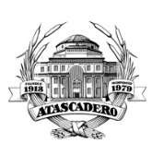
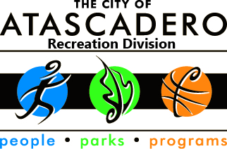
City of Atascadero
Recreation Division/Colony Park Community Center
5599 Traffic Way, CA 93422

2020 Concerts in the Park Band Application

All application packets must be received by DEADLINE

Friday February 7, 2020 at 5:00 pm.

Please ensure your application packet includes the following materials, to be considered: Completed application, Demo CD, Band Bio and Photo, and any other Supporting Materials.

PLEASE PRINT NEATLY

Band Name: _____________________________________________________________________________________
Music Genre (i.e., Rock, Blues, Country, Jazz, etc.):____________________________________________________
Contact Name (First, Middle Initial & Last): __________________________________________________________
Contact Phone Number:___________________________________
Email Address: _______________________________________________________________
Address:___________________________________ City & Zip:________________________
Band Website:________________________________________________________________
Number of Band Members:________
Do at least 50% of your band members reside in SLO County? (circle one)
YES NO
Please circle all the dates that your band may be available to perform (performance dates are not guaranteed):
June 13 June 20 July 11 July 25 August 1
August 22 August 29 Sept 5 Sept 12 Sept 19

Contact Signature:____________________________________________________________

Please mail or hand deliver to:
City of Atascadero/ Recreation Division
Attn: Jennifer Fanning
5599 Traffic Way
Atascadero, CA 93422

Questions? Contact: Phone # (805) 470-3490 Email: jfanning@atascadero.org

